System Architecture
GuestHouse Discovery Platform · COMP-311 Java Group Assignment · Manchester City Group · October 2026

1. Overview
The GuestHouse Discovery Platform is a discovery tool, not a booking system. Travellers browse guesthouses on a mobile app, and LocateBase staff manage listings through a web admin app. Both apps talk to one shared REST API, which stores its data in MongoDB. Using one API means the business rules (who can see what, which listings are public) are written once and applied to both apps.

2. Architecture at a glance
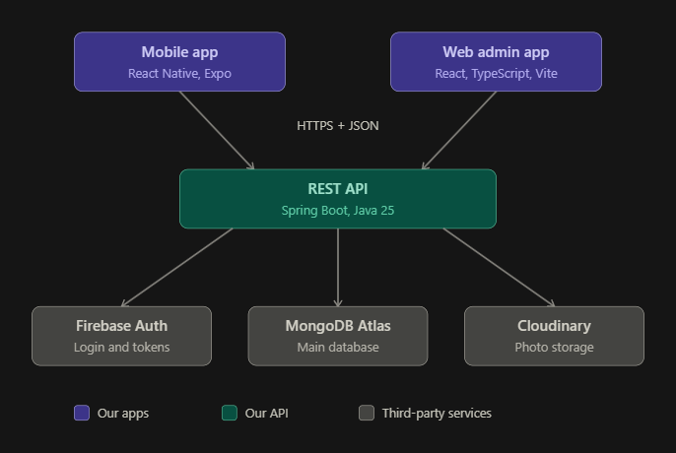
The system has three layers:
- Client layer: the mobile app (React Native with Expo) and the web admin app (React with TypeScript and Vite).
- Application layer: a single REST API built with Spring Boot (Java).
- Service layer: MongoDB Atlas for data, Firebase Authentication for login, and Cloudinary for photo storage.
Component | Technology | Responsibility
Mobile app | React Native, Expo | Browse and search guesthouses, view details and maps, rate, save favourites, contact admin
Web admin app | React, TypeScript, Vite | Owner registration requests, admin dashboard, guesthouse, user and request management
REST API | Spring Boot, Java | Business rules, validation, access control, data access for both apps
Database | MongoDB Atlas | Stores guesthouses, users, ratings, favourites, owner requests, messages and payments
Authentication | Firebase Authentication | Email and Google sign-in; issues login tokens
Image storage | Cloudinary | Stores guesthouse photos; the database keeps only the image links
Maps | Leaflet with OpenStreetMap | Draws maps in the apps from the latitude and longitude the API returns

3. Key flows

3.1 Browsing (no login)
The app calls the API's public endpoints to list, search, sort and filter guesthouses, and to open a single guesthouse. The API returns only guesthouses with the ACTIVE status, so drafts and suspended listings are never visible to the public. Results are paged so the app never loads everything at once.

3.2 Login and protected actions
- The user signs in with Firebase inside the app (email or Google).
- Firebase returns an ID token to the app.
- The app sends the token to the API in an Authorization: Bearer header.
- The API verifies the token with Firebase and looks up the user's role (customer, owner or admin) in MongoDB.
- The API allows or refuses the action based on that role.
Passwords never reach LocateBase's API or database, because Firebase handles them.

3.3 Listing a guesthouse
Owners cannot publish listings themselves. An owner creates an account on the web app and submits a listing request. An admin reviews it, and if approved, a LocateBase representative visits the guesthouse to collect photos, GPS coordinates and other details. Staff then create and publish the listing. Once published, the owner can edit details such as phone number and price, and run promotions, but cannot change photos.

3.4 Photo upload
Only admins upload photos. The admin app asks the API for a signed upload permission, then uploads the file straight to Cloudinary. The API stores the returned image link (up to 7 per guesthouse) on the guesthouse record. Image files never pass through the API or the database.

4. Data design
The database has seven collections: users, guesthouses, ratings, favourites, owner requests, contact messages and payments. A guesthouse's promotion is embedded inside the guesthouse document. Collections reference each other by id. Ratings and favourites act as junction collections, so both many-to-many relationships between users and guesthouses are resolved into one-to-many relationships. See the Entity Relationship Diagram for the full design.

5. Security design
Measure | Purpose | Status
Firebase token verification and role checks | Only logged-in users with the right role can perform protected actions | Planned
Server-side input validation | Rejects bad input before it reaches the database | Partly in place (search and paging checks); request-body validation planned
Safe database queries | User search text is treated as plain text, never as a query pattern | In place
Public listing filter | Draft and suspended guesthouses are hidden from the public | In place
Restricted cross-origin access (CORS) | Only the approved web app address may call the API from a browser | In progress
Secrets in environment variables | The database password is never stored in the code or on GitHub | In place
Rate limiting | Slows down abuse of login and write endpoints | Planned

6. Deployment architecture
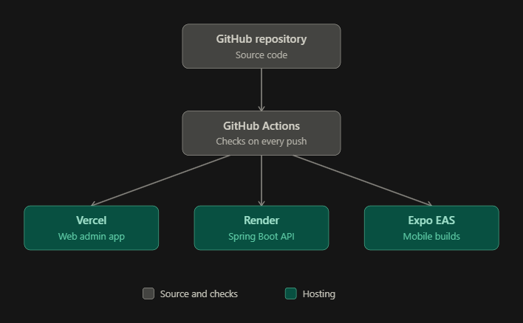
Code is stored in a GitHub repository. GitHub Actions runs automated checks on every push. The planned hosts are Vercel for the web admin app, Render for the API and Expo EAS for the mobile builds, all on free tiers suitable for coursework.
Current status: the API is not hosted yet. It currently runs on each developer's own computer against the shared MongoDB Atlas database, and the apps connect to it using a local address.

7. Design decisions
- One shared API: keeps the business rules in one place and lets the web and mobile teams work in parallel against the same contract.
- Firebase for login only: gives ready-made Google sign-in without building OAuth by hand, while all application data stays in MongoDB.
- MongoDB: satisfies the NoSQL requirement and supports geospatial indexing for location-based search.
- Cloudinary for photos: avoids storing binary files in the database and keeps loading fast.
- Staff-verified listings: protects the quality of the data, since every listing is checked on site.
Change from the original project write-up: the write-up proposed Node.js with Express for the backend. The team moved to Java with Spring Boot to match the course's Java focus. The rest of the stack is unchanged.

8. Current implementation status
- Done: project setup, MongoDB Atlas connection, guesthouse data model, sample data, standard error format, public list, search and detail endpoints.
- Next: CORS, Firebase login and roles, ratings and favourites, owner requests, owner and admin endpoints, API documentation and deployment.

